SCALING UP FROM SCIPS

Several tools are available to support lecturers in their understanding of inclusive teaching practice. One of these is SCIPS (Strategies for Creating Inclusive Programmes of Study). SCIPS is the result of a HEFCE funded project that was authored and managed by Dr Val Chapman (NTF) at the University of Worcester. SCIPS assists the academic community in developing a more inclusive approach to the design of teaching, learning and assessment strategies that will enable disabled students to participate more fully in Higher Education: https://scips.worc.ac.uk/project/.

Currently the SCALE Project (Student Centred Adult Learning Engagement in Higher Education) is in development. This is an Erasmus+ funded project lead by Richard Woolley and Sharon Smith at the University of Worcester. Along with partners in Italy, Poland and Spain we are developing a website which will supersede SCIPS. The website will be more specific in its information, using case studies and scenarios. This will support an online course to further lectures’ understanding of particular needs and approaches to learning and teaching.

The project provides resources and information relating to five key areas:
- Dyslexia, dyscalcula, dyspraxia
- Autism
- ADHD
- Physical needs
- Mental health and wellbeing
The website will have resources and a glossary of terms along with some ‘one sider’ information sheets signposting key information.
It is an exciting time for the project team as the website is under development and we look forward to sharing it with you soon. If you are interested in participating in evaluating the website then do contact us: Richard Woolley r.woolley@worc.ac.uk or Sharon Smith s.smith@worc.ac.uk
Further details about the SCALE Project are available at:
https://www.worcester.ac.uk/about/academic-schools/school-of-education/education-research/scale-project.aspx#:~:text=SCALE%20Project%20%2D%20University%20Of%20Worcester&text=Student%20Centred%20Adult%20Learning%20Engagement,colleges%20and%20other%20educational%20providers.
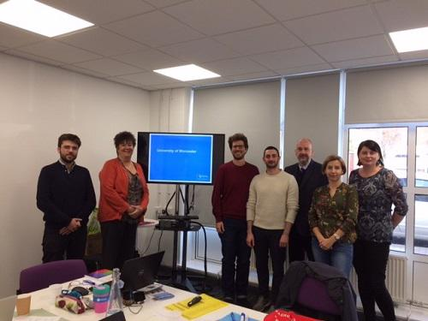
Pictured are Sharon Smith and Richard Woolley with members of the SCALE Project team at the launch in Worcester, November 2018 (Erasmus+ Project Code: 2018-1-UK01-KA203-048055).

